Dear Class of 1995,
When I began my internship with the Organization of Refuge Asylum and Migration (ORAM) in June, I was extremely excited. ORAM advocates for LGBTQI refugees and asylum-seekers through legal assistance, the training of relevant organizations, and the distribution of educational materials. I had been led to believe that throughout the summer, I would be traveling to Turkey, interviewing refugees, and returning to Tel Aviv to take their case and advocate for their resettlement through UNHCR. I would also be responsible for some administrative tasks—primarily fundraising for the small organization. I hoped to learn more about the process of refugee advocacy and gain experience in refugee law.
However, if there was anything that I learned from my summer working with ORAM, it is that nothing in the world of refugee advocacy and NGO politics is predictable. Due to changes in ORAM’s structure, its relationship with other NGOs, and in the international human rights regime more broadly, the organization was in a transitional phase throughout the summer. This inspired my curiosity about the ways in which different levels of the refugee system operate and interact, and motivated me to pursue independent interviews with both my employers and leadership in other NGOs in order to learn more.
First, ORAM is one of the only organizations in the world which focuses specifically on advocating for LGBTQI refugees, and because of its niche focus, is in a constant struggle for funding and resources. My supervisor, Jamie Charnock, was a 26 year old from England with a dry sense of humor and a warm demeanor—and he single-handedly kept the tiny organization functioning. The staff consists of two paid employees and an ever-rotating group of 6 or 7 interns focused on legal and administrative tasks. To address this, ORAM was in the process of merging with the American Refugee Association and moving to Berlin, and much of my job was allowing this merger to take place by compiling institutional histories, financial information, and taking thorough inventory. This merger was the result of years of negotiations and diplomacy between NGOs—a process new to me, the importance of which was underscored throughout the internship.
During this period, ORAM’s other focus was the distribution of ORAM’s promotional materials and publications to organizations aimed at the protection of LGBTQI refugees worldwide, and this task consumed the majority of my time at ORAM. These publications were designed to aide NGOs, governments, and UNHCR in the handling of LGBTQI refugee and asylum cases and promote best practices for advocacy. ORAM distributes these materials—as well as hundreds of in-person trainings—to maximize the number of refugees impacted by their expertise. Neil Grungras, the Executive Director of ORAM, explained the significance of these training materials. “If we take one case, we help one refugee. But if we teach a hundred organizations how to properly protect these vulnerable populations, we will eventually reach hundreds of refugees.” This distribution was incredibly challenging, as the presentation of the materials was extremely delicate, especially in countries where even discussing LGBTQI rights put organizations at risk.
ORAM did take on several individual client cases this summer, but their ability to take on client work was severely reduced due to both the aforementioned funding challenges, and a reduction in the willingness of third countries to accept resettled refugees. Due to more restrictive policies on resettlement in the US and Western Europe, the process of refugee processing—especially with regards to Syrian refugees—had essentially come to a halt. Thus, taking on more Syrian clients was inefficient for ORAM, since slots for their resettlement were simply not available. Although I cannot go into details regarding the several clients ORAM did have during my time with the organization—and was not privy to many of the details myself—it was clear that they were in a state of extreme vulnerability with little hope of salvation through UNHCR or other institutional processes. ORAM wrote letters urging NGOs, UNHCR, and the Turkish government to act, but the ability of UNHR or other NGOs to improve their circumstances was limited by a lack of cooperation by relevant national governments. Our clients only real option was to flee Turkey—and it was an option ORAM could not officially advise them to take.
Although I was unable to become directly involved with client work at ORAM, I was able to learn more about the process of individual advocacy from my colleagues, as well as manage ORAM’s “help account.” This email account is available to refugees and asylum-seekers worldwide, and allows them to approach ORAM with questions regarding their status and how they should proceed to secure their safety. I was trained to respond to these inquiries and refer refugees to local NGOs which could provide specific legal advice or basic humanitarian services. This portion of my job was extremely powerful, because it illustrated both the impact organizations like ORAM can have on the lives of individual refugees, and the limitations in the ability of any one NGO to protect vulnerable populations.
While in Tel Aviv, I wanted to learn more about the different ways in which relevant NGOs are structured and focus their efforts in order to maximize their impact on refugee populations, and in order to do so I supplemented my work at ORAM by volunteering part-time with the Eritrean Women’s Center and conducting interviews with actors in local NGOs. The Eritrean Women’s Center was more focused on individual assistance within the Center and system-wide change through media campaigns and publicity. The Center was geared towards meeting the needs of the vulnerable Eritrean refugee population in Israel. Eritreans in Israel have fled persecution, violence, and forced military service by the dictatorship in their own country, and face extreme danger in the Sinai and detention centers before reaching Tel Aviv. Since they have not officially been granted refugee status there, only temporary residency permits, they have no access to social services. The government periodically attempts to force them to “voluntarily” leave the country through a series of taxes and discriminatory policies, rather than officially deporting them and risking a violation of international law. At the Center, I helped with small administrative tasks and was trained to help asylum-seekers fill out RSD forms and applications for resettlement or individual sponsorship in Canada. This process involved interviewing individuals about their experiences in Eritrea and their journey to Israel, and ensuring that all paperwork was properly completed so that—should the Israeli government begin to actually review these documents—they would theoretically have a clearer path to refugee status and the protections they deserved under international law. I asked my supervisor, Andrea Gagne, if other nations might be able to pressure Israel into changing their treatment of Eritrean refugees, but she expressed doubt at the power of diplomacy from outside Israel to shift the thinking. Rather, she said, “change requires internal motivation. Our best hope are the courts.”
This position also enabled me to speak with the leaders of other NGOs aimed at advocating for Eritrean refugees, and explore the different approaches taken to meeting their needs. Some organizations focused on fighting for legal victories in Israeli courts to systemically change the position of Eritreans in Israel; others, like the EWC, were more focused on direct client support—fundraising for food, providing medical services. I learned from Jamie, my supervisors at the EWC Andrea and Taklit, and professionals at other NGOs that at each level of the “process,” NGOs faced fierce competition for funding that discouraged cooperation between them and made a systemic, multi-layered approach to advocacy difficult to achieve. I discovered that diplomacy between NGOs was as crucial as the face-to-face trust building I assumed NGOs engaged in with UNHCR and national governments. Most importantly, I discussed with Jamie which “level” of the refugee regime needed to function better in order to most improve the protections available to vulnerable populations. “Ultimately,” Jamie and I concluded together across many conversations, “if the national governments want the refugees out and won’t cooperate, or if they won’t accept any resettled refugees—what everyone else can do is very limited.”
This fall I am working as a Legal Intern with my ORAM colleague Christina de la Peña at the Anti-Violence Project in NYC, working with individual LGBTQI asylum cases. However, these conversations did more than increase my interest in refugee and asylum law. Coupled with recent trends in American politics, I have come to have a deeper understanding of the dramatic impact individual leaders and policymakers at the national level can have on the international human rights regime. This summer inspired me to take a greater interest in local government and politics and the relationship between national policy and the efficacy of international institutions. I am extremely grateful for the opportunity that the Class of 1995 gave me to explore this issue. The funding I received in this Program allowed me to live in Tel Aviv for the summer, commute to and from interviews and work, eat, and access basic necessities. If not for this funding I would not have been able to pursue this opportunity, and certainly would not have been able to take on two jobs as I did with ORAM and the EWC. Thank you for the opportunity to learn so much, not only about how to serve refugee populations—but about how to think critically about the best way to serve those populations, and analyze how a given organization, institution, or system may or may not be maximizing effectiveness.

Sincerely,
Maya Aronoff
(photos below)

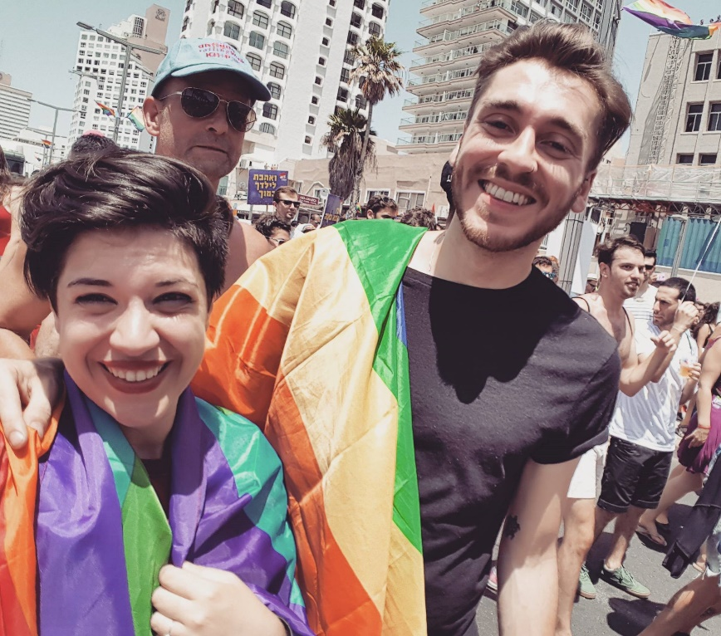

My supervisor Jamie Charnock and my immediate supervisor Luna Libboni at Tel Aviv Pride

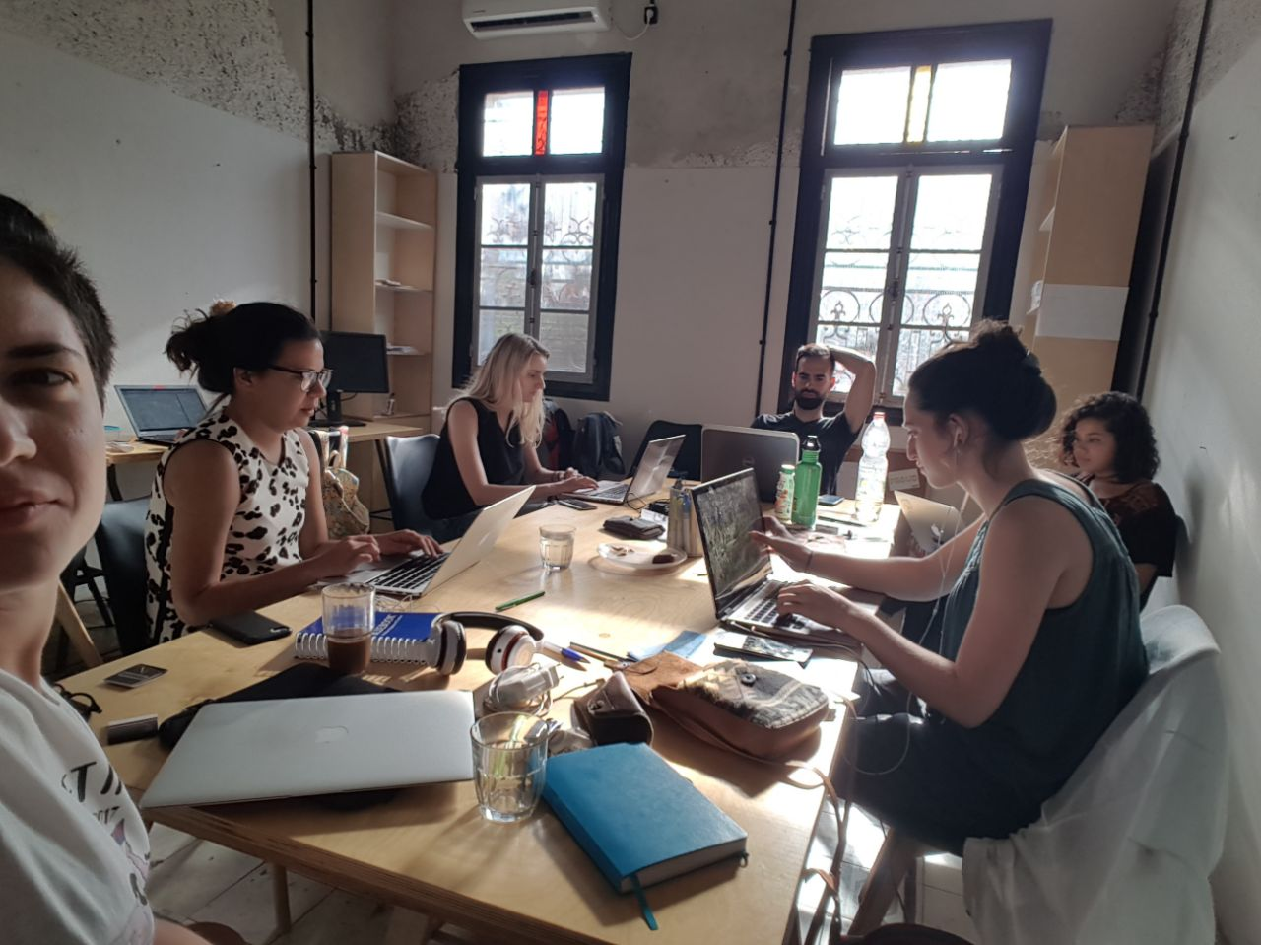

ORAM interns hard at work

