I spent my summer working in Amman, Jordan at 3DMENA, an engineering organization focused on social and humanitarian innovation, specifically in sustainably alleviating the Syrian refugee crisis in Jordan. A typical day consisted of leaving the house in the morning and spending anywhere from 5 – 30 minutes hailing a taxi (after which, I would always opt for the more expensive Uber option). Amman is a rather small city but one that is horribly congested and lacking in public transportation such as a metro system. Because of this, hailing a taxi is a challenge, and, once you’re in one, an obvious foreigner with broken Arabic like myself has to undertake the additional struggle of ensuring he isn’t cheated for his money from the taxi driver taking a longer route or “forgetting” to turn on the meter. But after stretching and straining into these realities of everyday life in Amman, this struggle wore onto me, and I have endearing memories of many pleasant conversations with taxi drivers during my daily ride to King Hussein Business Park, the location of my work.
The office is a maker space lined with 3D-printers and other nifty machinery. 3DMENA incubates various technologies it believes has market potential to be used in humanitarian innovation, and I would work daily with my team to refine prototypes for some of these incubation projects. One of my main projects during the summer was to make an open-source prosthetic hand more economical for use by refugees whose limbs had been amputated from war in their home country. The goals were two-fold: 1. to use 3D-printing to manufacture the prosthetic hands since additive manufacturing made possible by the 3D-printing revolution has the potential to significantly drive down the cost of traditional prosthetics, 2. to alter the source code to make the hand operable with a cheaper Arduino microcontroller rather than the more expensive printed circuit board for which it is designed.
Another project I helped with, along with other interns from MIT, was a refined prototype for a Do-It-Yourself (DIY) greenhouse climate control system. Our team used an Arduino microcontroller, various electric circuitries, a thermoelectric cooler and fan, and climate condition sensors to develop a prototype for this system that provided just the right climate conditions to grow foods such as vegetables and fruits. The system already has funders, and the long-term vision is to cheaply scale it 2-3x and implement it in a refugee camp in Jordan to alleviate food scarcity and also encourage agricultural micro-business in the camps.
Other tasks I completed were, for example, helping translate DIY and educational manuals between English and Arabic that the company still uses in its workshops and educational initiatives. I also was exposed to the less engineering and more entrepreneurial aspects of a high-impact organization like 3DMENA. For example, I worked with the CEO and team on the business model and preparations for the opening of FabLab Irbid (Irbid is a city north of Amman). The FabLab concept was started at MIT in 2001, and since then many FabLab’s have opened throughout the world that serve as small-scale workshops equipped with digital fabrication and manufacturing tools that allow society to come together to innovate. FabLab Irbid is the first digital fabrication lab in Jordan, and it finally opened up with a grant from the EU just a few months after I left Jordan. Its mission is to attack unemployment and economic stagnation by bringing together the Jordanian civil population and refugees to encourage joint innovation and business development.
Perhaps the most meaningful part of my trip was in my interactions with refugees through workshops. I helped design and conduct multiple hands-on tech workshops during my stay in various refugee centers throughout the city, and 3DMENA still executes these workshops with youth in Jordan. Unfortunately, many refugee youth have been out of school since leaving their countries because the Jordanian gov’t has regulations against allowing them into the public school system to re-establish normalcy in their lives. That’s why these centers and volunteer workshops are so important to fill that educational void. One workshop we conducted was with Syrian and Iraqi refugee youth to build a DIY solar-powered battery. We taught them the basics of electronics and energy in the Middle East, soldering, and programming a basic website to monitor the charging of their battery. Another focused on teaching them basic Arduino programming and 3D-printing that culminated in the group building their own Arduino-controlled RC cars. I deeply miss these wonderful people, their soft wisdom, their keen interest, their witty jokes, and their sad stories they shared through unperturbed smiles. I miss the way one refugee struggled to speak English with such care and calculation, like he respected it so much. “One day, I hope to watch an entire Youtube video in English without no translation and understand it all.” I still help him with his English, and he with my Arabic. I also miss that special feeling when you see these kids triumphantly holding their working circuit boards that they soldered with their own hands. Faisal, a 13-year-old from Iraq told me, “I haven’t done anything like this in my life. And it’s hard! But it’s so cool!” That alone made it all worth it for me.
Finally, there is so much to be said about Jordan at large. I resolved to make the most of my time outside of work to explore this country I came to love. I practiced my Arabic daily with locals who (inevitably) wore well-intentioned chuckles. I explored Amman with newfound friends in all its glorious Roman ruins, storied souks, and delicious cuisine. I also made some time to travel throughout Jordan (a small country about the size of the state of Virginia). I explored the famous ancient Nabatean city of Petra; I climbed the magnificent sandstone mountains of Wadi Rum that Lawrence of Arabic famously chronicled in his Seven Pillars of Wisdom; I floated in the Dead Sea, the saltiest sea in the world in which (due to its extremely high density), it is nigh impossible to sink; and I scuba dived in the coral reefs of the Red Sea at the historically and religiously significant seat port of Aqaba.
This was my second summer in Jordan. I spent my first there studying Arabic. Many of my friends have asked me why I returned to the same country a second time after already having gone once. But I believe there is a certain beauty in squeezing everything wonderful out of a place you visit. And for me, what began in my freshman year as a hobby to learn a new language has subsequently transformed into a deep passion to help, and learn from, humanity. Jordan is simply a wonderful country that I’ve embraced with open arms, and it holds such a deep place in my heart. I am indescribably grateful to my Princeton class funding sources for giving me the opportunity to experience such a meaningful and impactful summer, and I’m counting the days until I can return to Jordan and continue doing what I love.

Some Pictures (All pictures taken on my Nikon D3300)
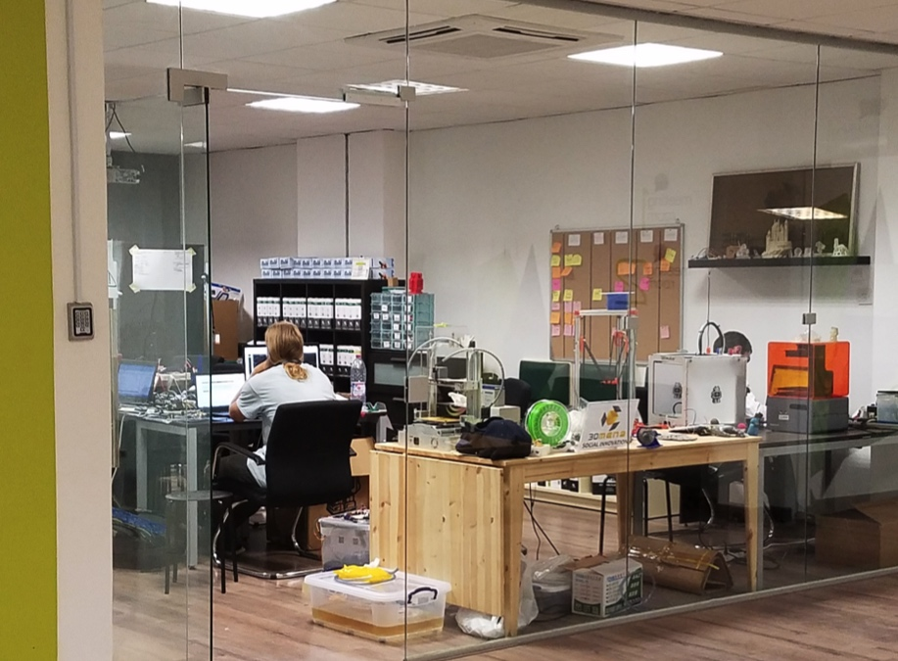
A view of the 3DMENA office where I worked

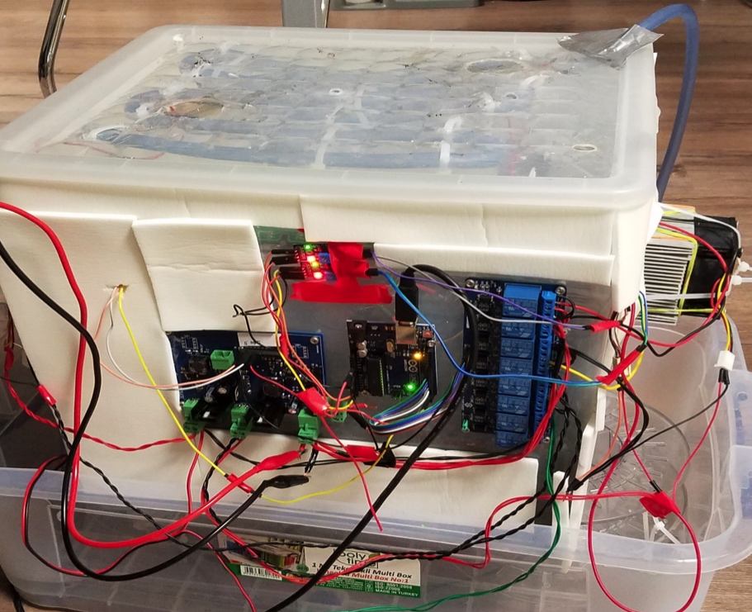
The climate control system prototype
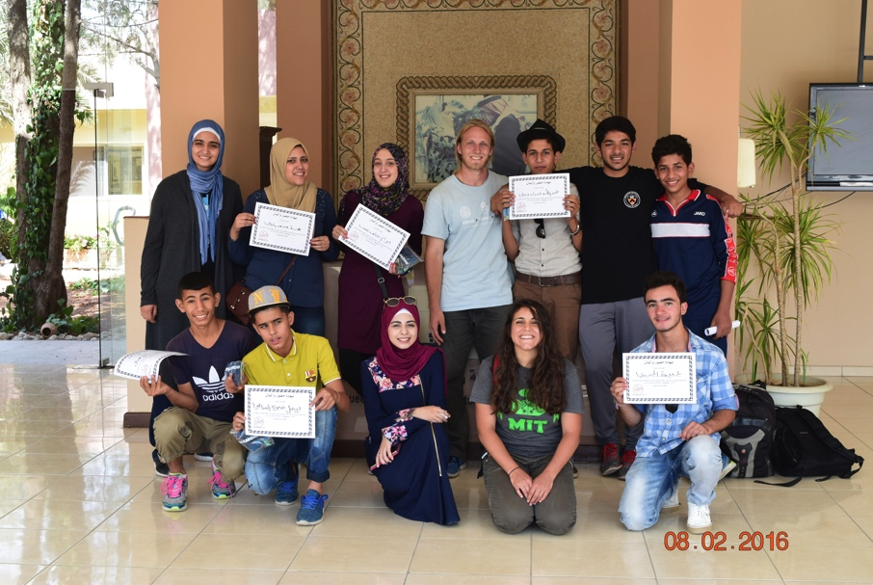
A picture with the students of the solar-powered battery workshop. I’m in the back row, second from the right in the black shirt.

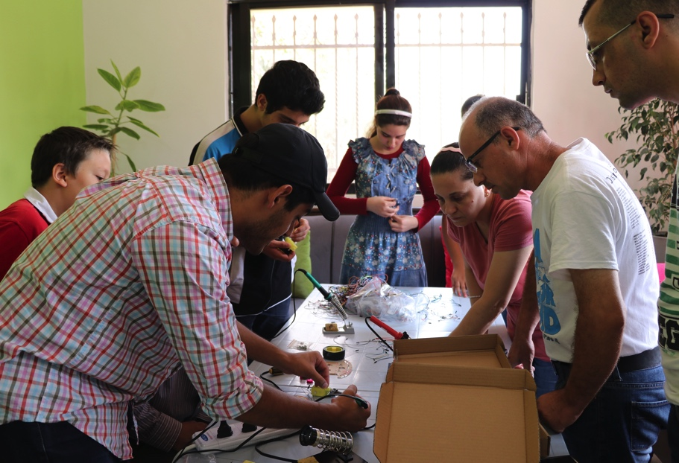
Teaching the workshop participants how to properly solder. I’m wearing the black cap.

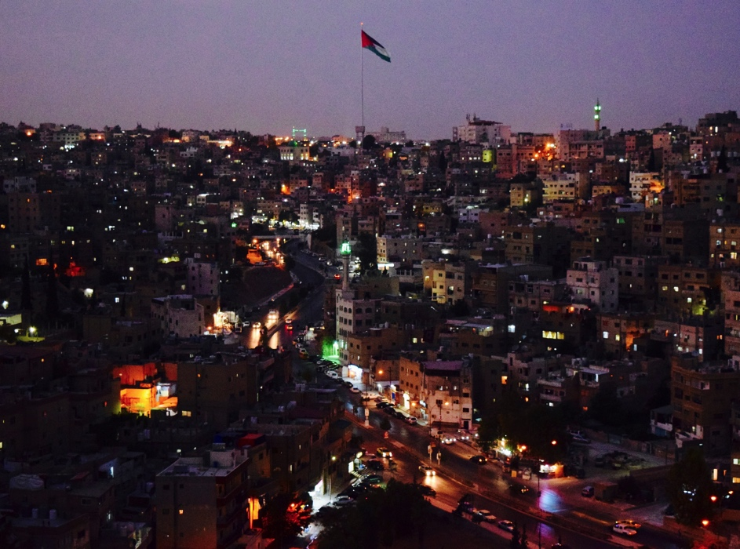
A view of Amman from the ancient Temple of Hercules at sunset

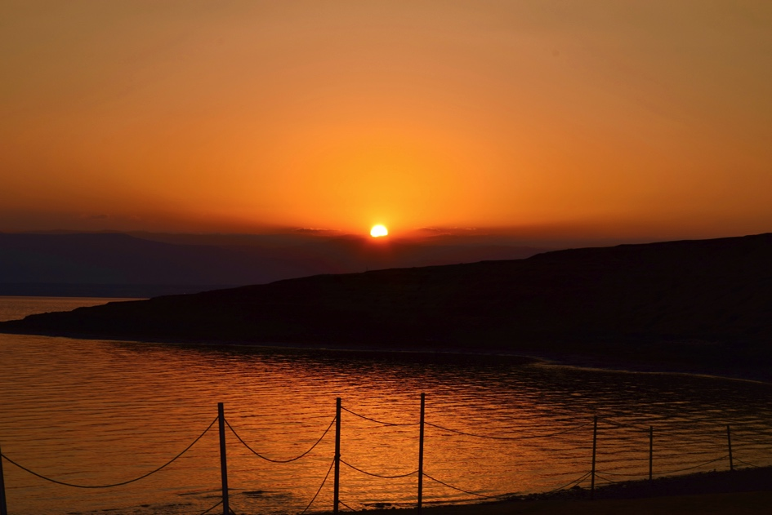
A view of the Dead Sea at sunset

