Post Trip Report: Agua Potable Para Pusunchás
Susannah Crowell, Summer 2017
Leading the implementation trip to Pusunchás, Peru this past summer was a fascinating culmination to a year of project management and design, a 5-week marvel of creation and transformation. The CAD models of storage tanks I made throughout the year came to life from an elixir of water, cement, sand and sweat; the distribution lines evolved from Google Earth schemes, to powder marks, to 40cm trenches, to buried PVC pipe filled with water. Spending 7AM – 7PM every day surrounded by Spanish strengthened my language ability and consequently my relationships to our community and NGO partners. The water committee, or JASS, of Pusunchás, was a truly inspiring group to work with who stopped at nothing to make the project happen, while our NGO partner, the indefatigable and hilarious Julio Avalos, brought years of experience and advice on how to attack our many challenges. The experience overall impressed on me how much development work is truly engineering, problem-solving work that is not only morally compelling but fascinating in itself. I was not just motivated by the goal of increasing clean water access, but for the process itself, of sustainable engineering, relationship-building and project management.

Overview
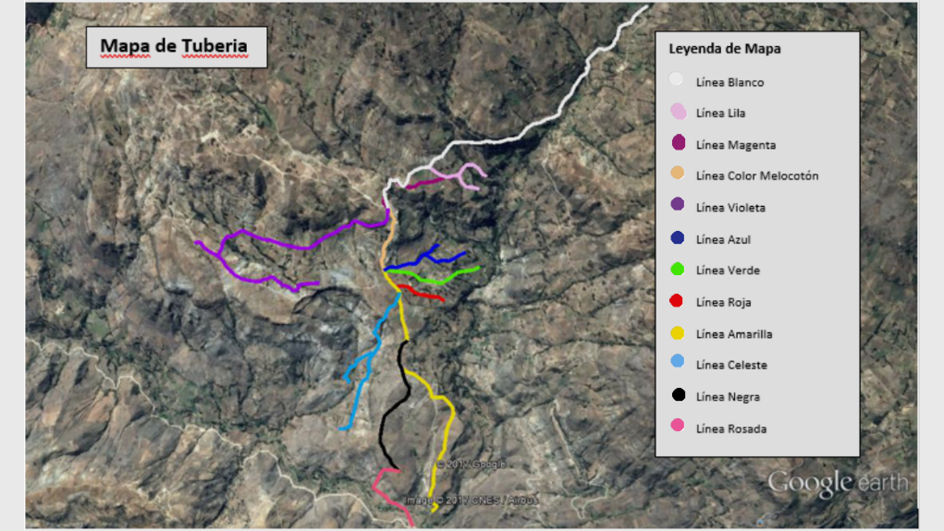
Pusunchás is a rural community located near Otuzco, in the La Libertad region of the Peruvian Andes, and like many communities in the area, their main priority is obtaining a reliable source of daily water supply. From data collected in the summer of 2016, we spent the academic year designing a 20km gravity-fed potable water system, sourced by a natural spring which the community purchased in 2016. During this implementation trip, in the summer of 2017, we completed construction of Phase I of the project. The goal of Phase I was twofold: build the conduction line (Linea Blanca) to bring water to the reservoir above the community, and install two distribution lines (Linea Violeta and Linea Melocotón) to reach tapstands in two parts of Pusunchás, including the school.

The Conduction Line: Source Capture to Reservoir

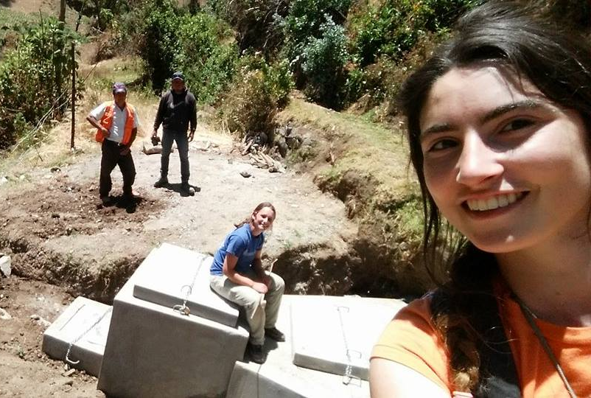
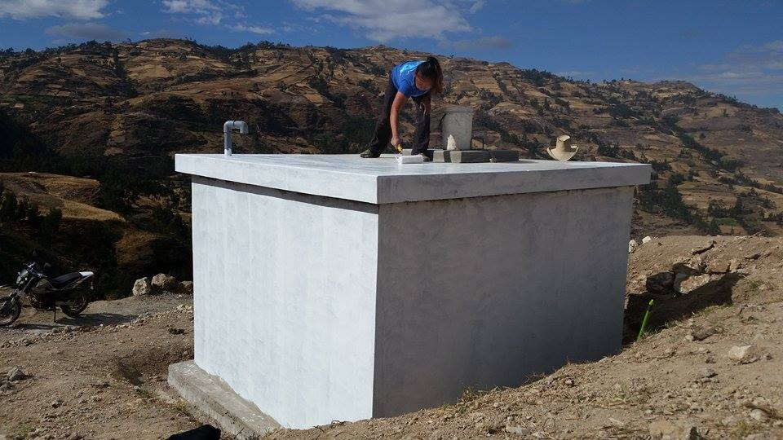
The purchased source is situated almost three kilometers away from Pusunchás in a separate community, although the source itself was purchased by the water committee or JASS of Pusunchás in 2016. Therefore, the first main goal was to construct the entire 2.8km conduction line to bring water to the community, including building the source capture (see below left) and a 10,000L reservoir (see below right). This required that the JASS obtain written legal trenching permission from every individual that owned land along the pipeline route, most of which were procured before EWB-Peru arrived. For the construction of the concrete components, we hired a team of experienced masons led by Tito Roberto Garcia Meza, whom EWB-Princeton has worked with for the past several years. Along with our main NGO partner, the Marianistas, EWB-Princeton was responsible for the logistics and transportation of materials for construction, supervising the work and holding each actor accountable. The community, led by the water committee or JASS, was responsible for providing manual labor to the masons as well. The primary responsibility of the community, however, was organizing and providing labor to makes trenches for the pipeline, then bury the pipe after it was laid by EWB-Princeton.

Distribution: Getting Water to the Tapstands

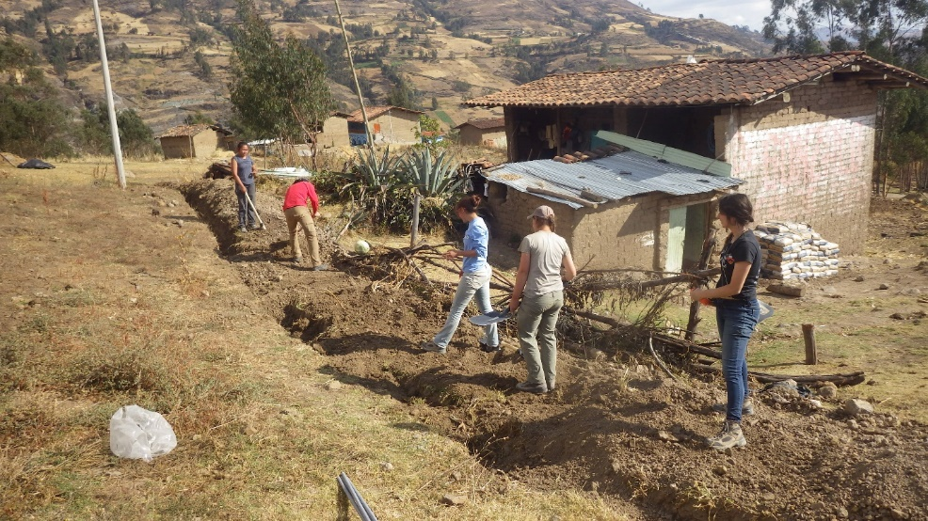
The second major goal was the installation of two distribution lines to community sectors Progreso and to the school in Central, including the construction of three pressure breaks (concrete storage tanks) and thirteen tapstands. Nine of these tapstands are located in the sector of highest altitude, called Progreso, while four were build in the sector Central, including a tapstand next to the school. The construction of these concrete components was also led by a team of masons under Tito, while the community was responsible for digging trenches for the pipeline, then burying the pipe after it was laid by EWB-Princeton. Inevitably, EWB-Princeton would help cover the pipe as well (see left). In total, distribution lines required another 4.5km of pipeline, of which we were able to lay the 1.3km to reach Central during the trip while the 3.2km to reach Progreso were laid afterward under the hired supervision of Tito, with regular communication with the team back in Princeton.

Challenges: Legal and Community

While technical difficulties were numerous, all such problems could be resolved given another day or two to identify and transport the correct tools and materials. Rather, the main challenge of the implementation trip that often held up progress was twofold: community organization and legal permissions to trench. These two challenges were directly related. For the duration of the 5-week, one family that owned a large piece of land along the conduction refused to provide trenching permission, motivated supposedly by a long-standing rivalry with a different family that was part of the project. When community members heard that these permissions were missing along the conduction line, then many would not show up for trenching work on other sections of the system. While the JASS existed before this project as the main governing body in Pusunchás, it was clear that a project of this scale tested and challenged their capacity to organize workers and hold them accountable, to maintain their respect and communicate well. Ultimately, the JASS was able to both obtain legal permissions after appealing to the local government in Otuzco, as well as reorganize the labor breakdown based on community feedback.

Lessons Learned

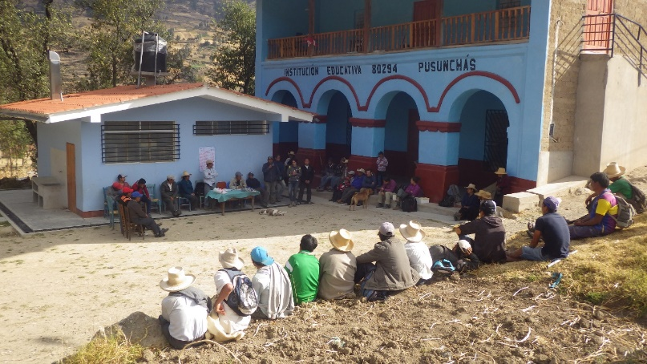
Despite setbacks, all major construction goals were accomplished and there is currently water filling the reservoir and flowing at all thirteen tapstands. Both as a project manager, and as an engineer invested in international development, this trip taught me a lot about collaboration, especially as applied to development work. Early in the trip, we interacted with the JASS but had not addressed the community as a whole. When many people failed to show up to work, we questioned how effectively they were communicating and organizing. By having a large community meeting (see below), we were able to directly address people’s questions and concerns, learning ourselves what issues and rumors were discouraging or preventing them from more actively working for the project. These meetings made clear that oftentimes the leaders of a group cannot speak for all of the members; project managers cannot lead effectively without hearing and considering everyone’s perspective.
Considering many community members’ attitudes, it was decided near the end of the trip that for future implementation years, community members would only be responsible for trenching to their individual community sectors rather than everyone working to complete each other’s lines, and that they should complete this trenching before the travel team arrives in August each year. In this way we will be able to manage time in country better and have more time for testing and maintenance.
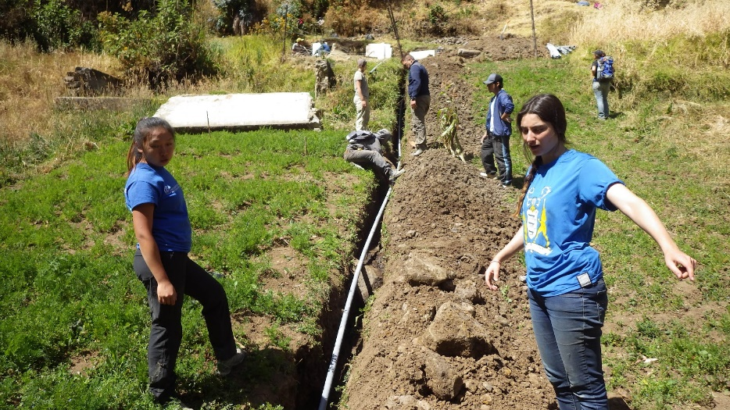
On a more personal note, I learned what it meant to be a leader in the field rather than on campus. I was not just the leader at a meeting, or managing via emails behind the scenes, but All. The. Time. When issues arise throughout the day, every day, someone needs to make a decision even when there is no clear best path. There were a thousand moments where I heard, after a few minutes debate over the best course of action: “Okay, Susannah, what’s your call?” Yet these problems that are presented each day are only half the battle; the other half is planning, at the beginning of each week or day, how to avoid or minimize the amount of issues coming up in the first place. As tiring as this sometimes felt, the experience was also incredibly empowering. One can’t help but feel like a literal boss after saying a thousand times: “Okay guys, this is what we’ll do.”

THANK YOU

I’d like to offer A HUGE thank you to the Class of ’95 Summer Service Fund for supporting the project! I really loved the trip and enjoyed being a leader in the field, while simultaneously feeling incredibly humbled by both the challenges and the determination and ingenuity of our Peruvian partners to overcome them. Being Project Manager of EWB-Peru has been my most transformative and challenging experience at Princeton, and this implementation trip was an epic culmination of that experience; it validated my optimism that not only can I make an impact on this complicated, crazy world, but also that I relish doing so. The work was meaningful and made me happy, and now that I’ve experienced it I will seek nothing less for my future self. So once again, thank you!

